**PRACTICAL NO 4**

AIM :- Forensics Case Study : Solve the Case study (image file) provide in lab using Encase Investigator or Autopsy .

Software Required:Autopsy

Step 1 : Open Autopsy

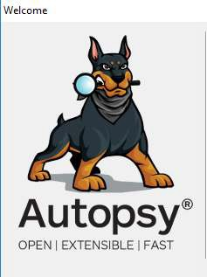

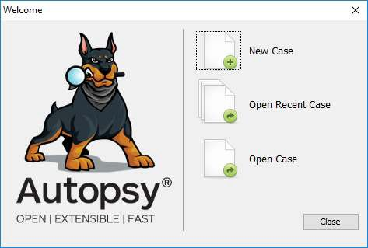

Step 2 : Click on new case

Step 3 : Enter details regarding the case and click on next button.

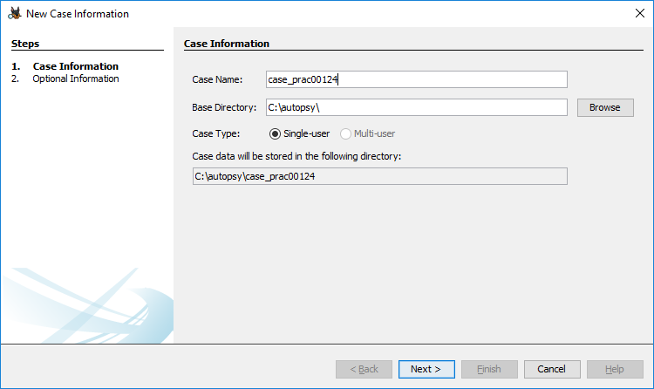

Step 4 : Enter further details and click on next button

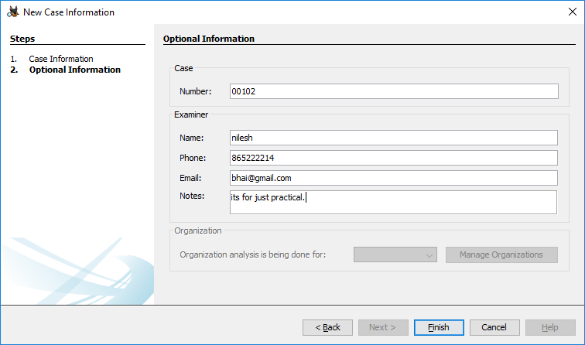

Step 5 : Now here we have to select Type of data source to add , in our case disk image or VM file and click on next

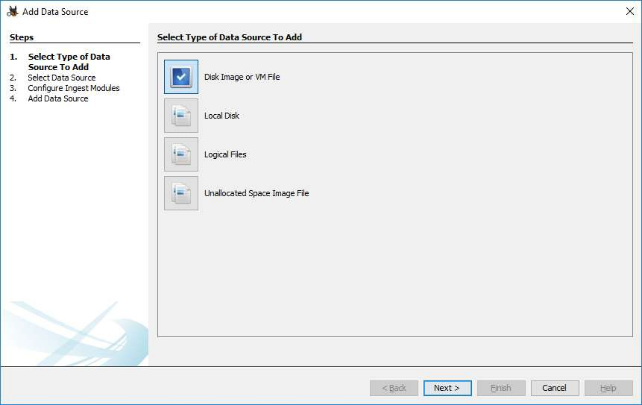

Step 6 : Now we have to select image file and click on next button

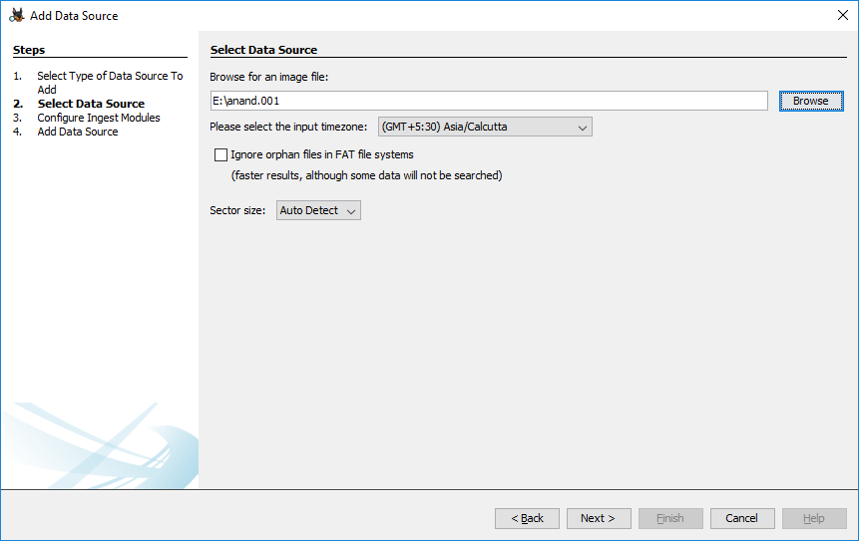

Step 7 : Now click on select all in order to Run ingest modules on: and click on next.

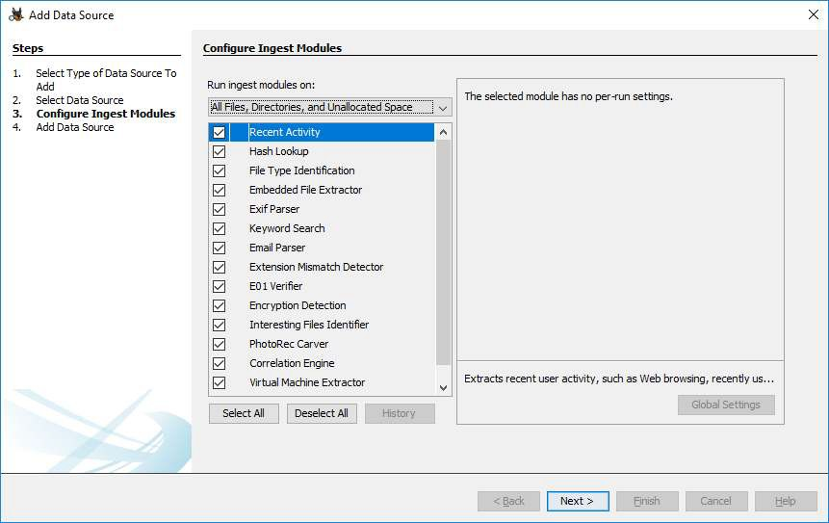

Step 8 : Now click on finish

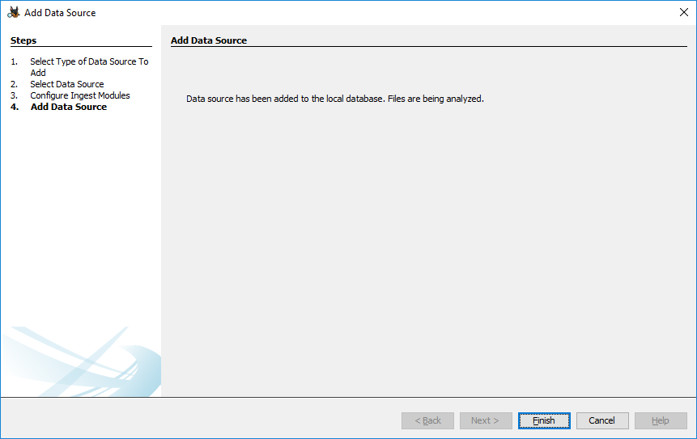

Step 9 : Now Autopsy window will appear and it will analyse the disk that we have selected .

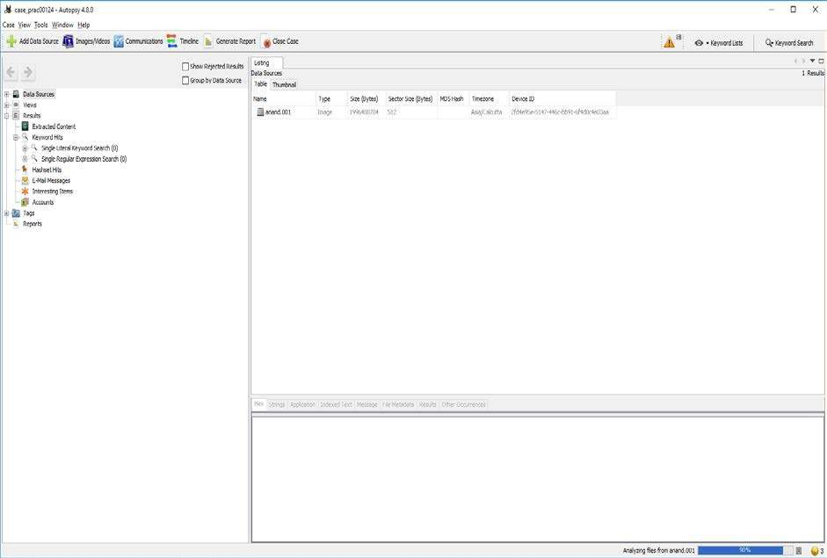

Step 10 : All image files appears in the Table tab. Select any file to see the data

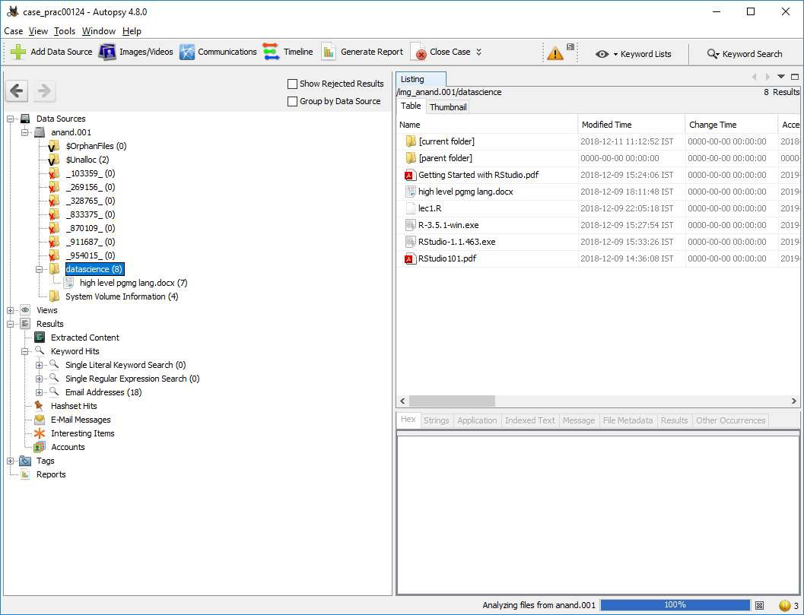

Step 11 : Expand the tree from left side panel to view the document files.

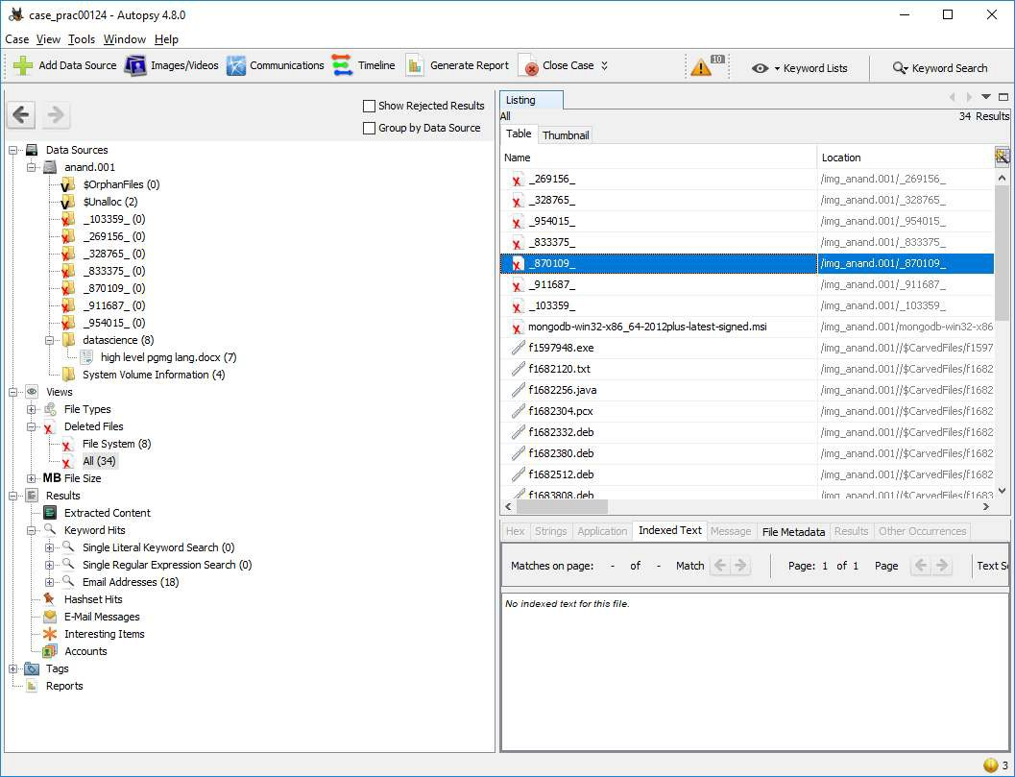

Step 12 : To recover the files , go to view code → Deleted files node , here select any file and right click on it then select Extract files option

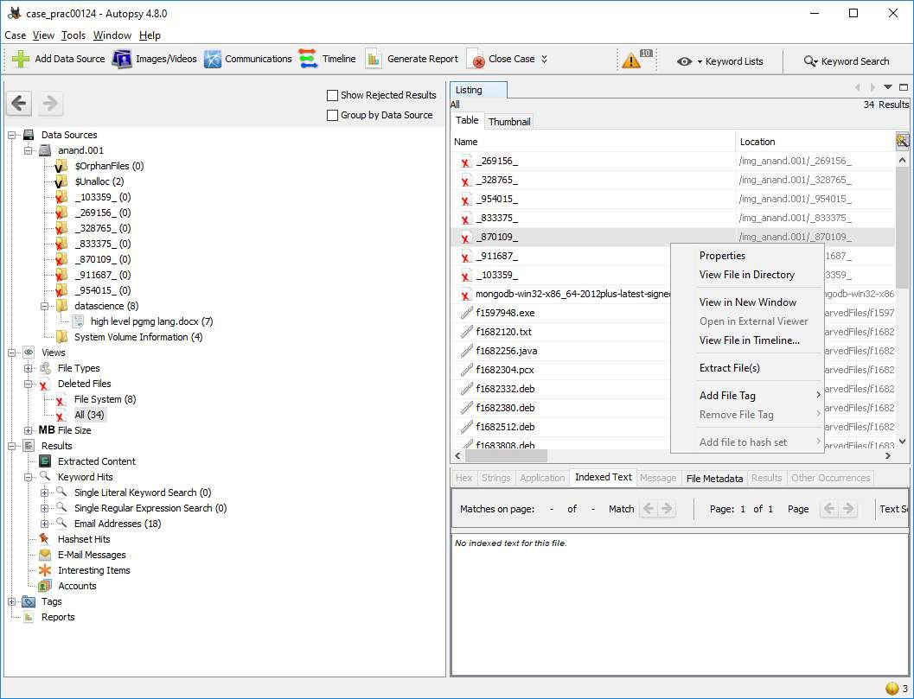

Step 12: Select Path where you want to save extracted file and click on save .

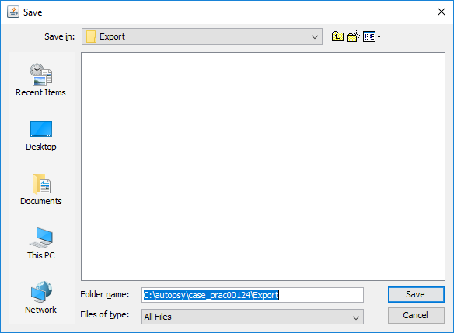

Step 13 : Now click on OK

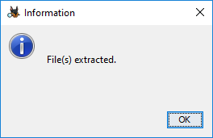

Step 14 : Now go to C:\autopsy\case_prac00124\Export folder to see recover file

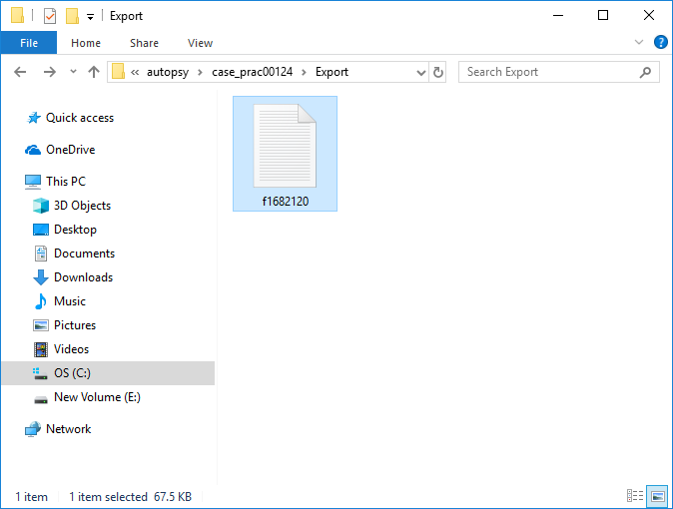

Step 15 : Click on generate report from Autopsy window and select the Excel format and click on next

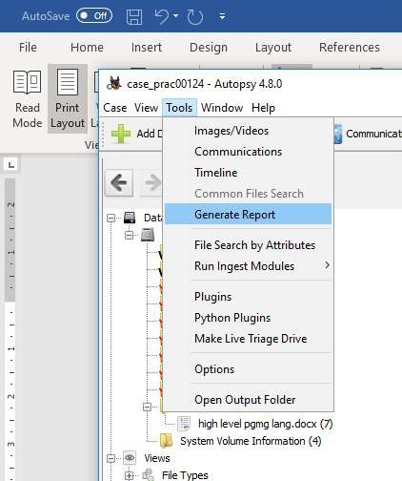

Step 16 : This window will appear

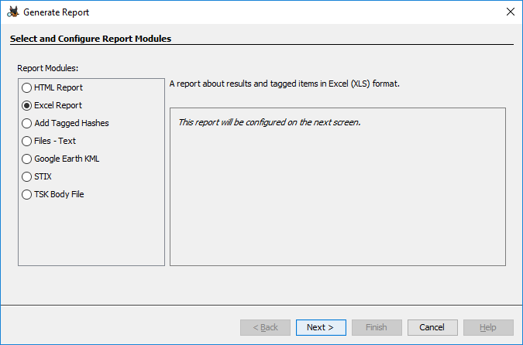

Step 17 : Now report is generated so click on close button. We can see the Report on Report Node

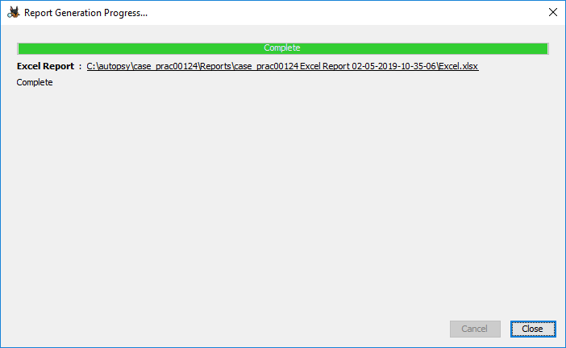

Step 18 : Click on report

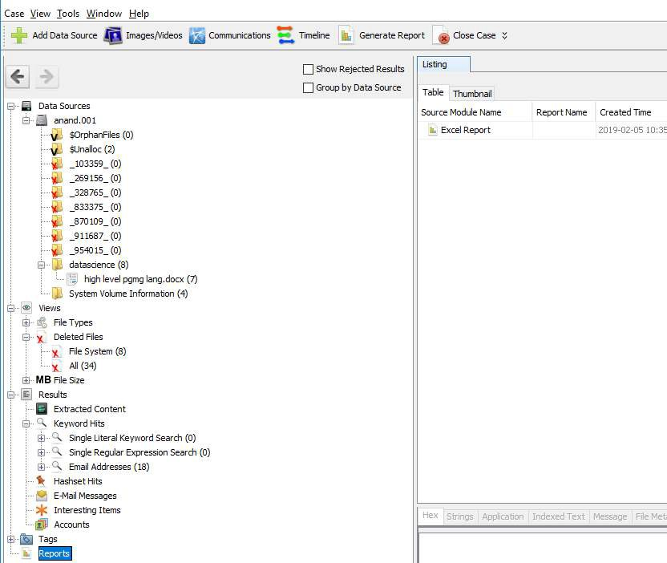

**Conclusion:**Thus,we have studies how to solve the Case study (image file) provide in lab using Encase Investigator or Autopsy .

**PRACTICAL NO 5**

**AIM :** Capturing and analyzing network packets using Wireshark (Fundamentals).

* Identification the live network
* Capture Packets
* Analyze the captured packets

**Software Required**:Wireshark

## Capturing Packets

Capture traffic on your wireless network, click your wireless interface.

You can configure advanced features by clicking Capture > Options, but this isn’t necessary for now.

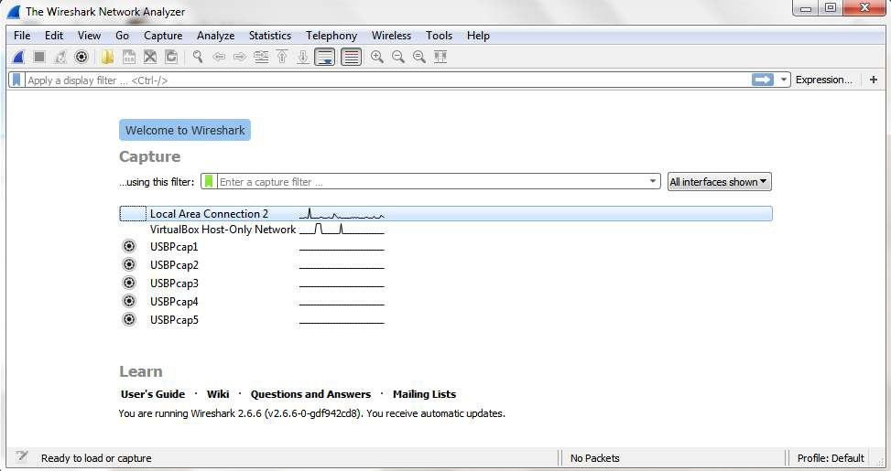

As soon as you single-click on your network interface’s name, you can see how the packets are working in real time. Wireshark will capture all the packets going in and out of our systems.

checkbox is selected and activated at the bottom of the window. The checkbox says “Enable promiscuous mode on all interfaces”.

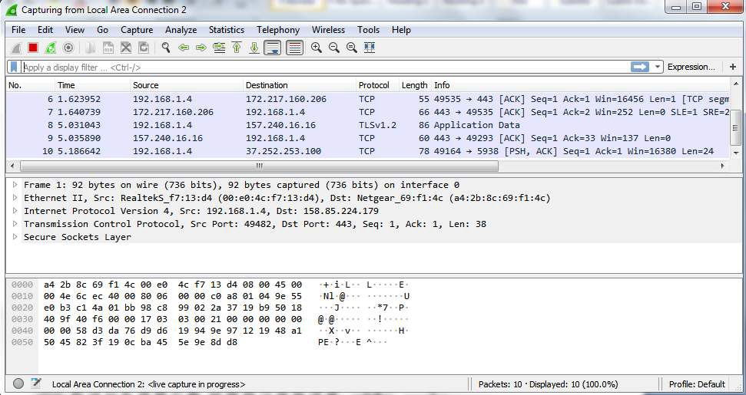

The red box button “STOP” on the top left side of the window can be clicked to stop the capturing of traffic on the network.

## Color Coding

Different packets are seen highlighted in various different colors. This is Wireshark’s way of displaying traffic to help you easily identify the types of it. Default colors are:

Light Purple color for TCP traffic Light Blue color for UDP traffic

Black color identifies packets with errors – example these packets are delivered in an unordered manner.

To check the color coding rules click on View and select Coloring Rules. These color coding rules can be customized and modified to fit your needs.

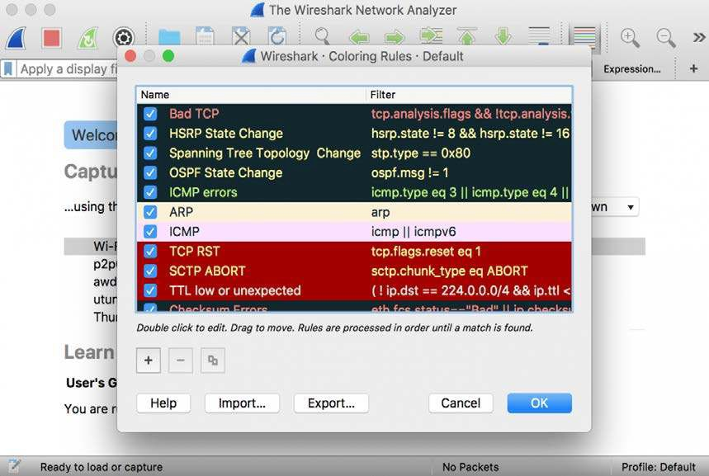

## Analyze the captured Packets:

First of all, click on a packet and select it. Now, you can scroll down to view all its details.

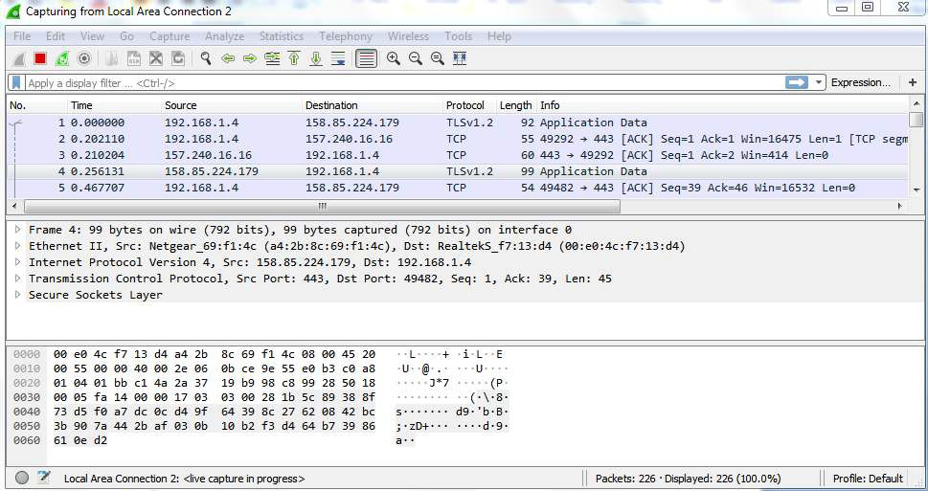

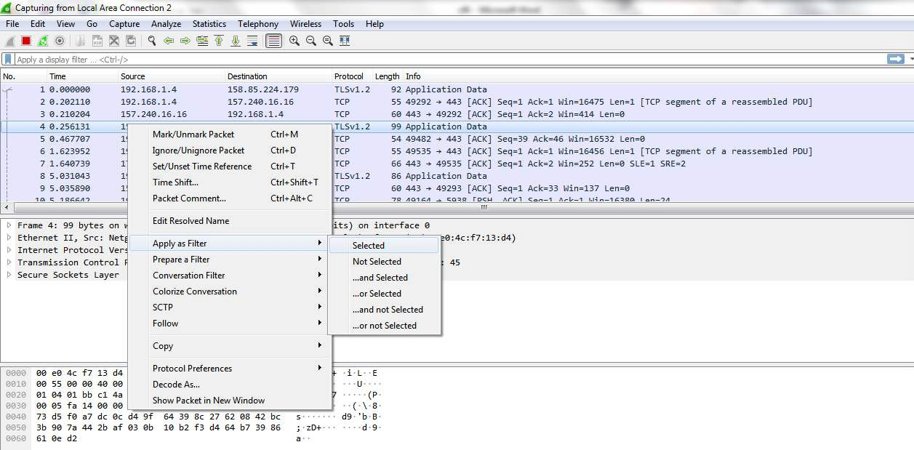

Filters can also be created from here. Right-click on one of any details. From the menu select Apply as Filter drop-down menu so filter based on it can be created

## Display filter command –

1. Display packets based on specific IP-address
   * ip.addr == 192.0.2.1

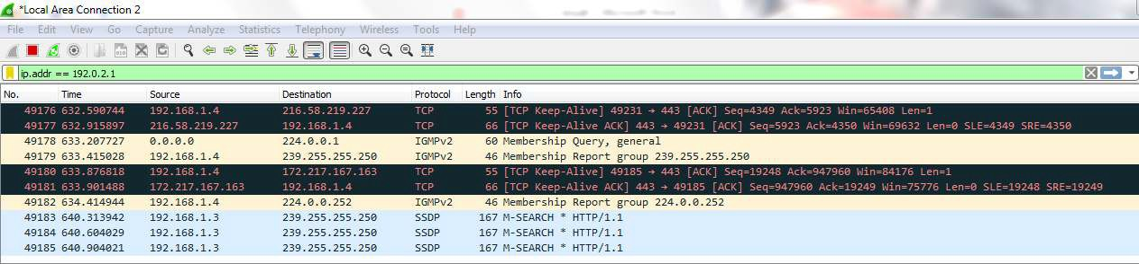

1. Display packets which are coming from specific IP-address
   * ip.src == 192.168.1.3

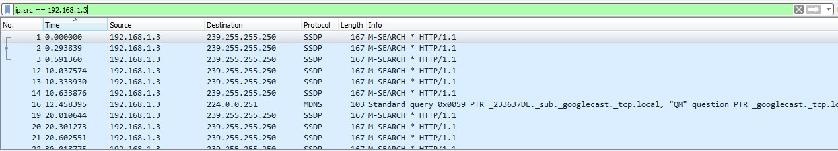

1. Display packets which are having specific IP-address destination
   * ip.dst == 192.168.1.1

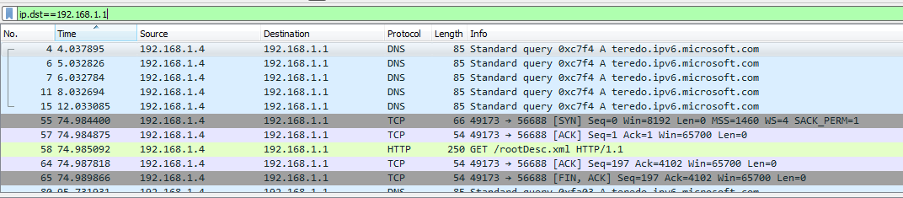

1. Display packets which are using http protocol
   * http

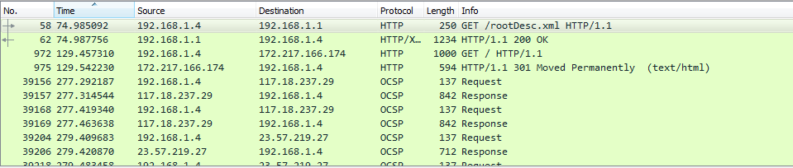

1. Display packets which are using http request
   * http.request

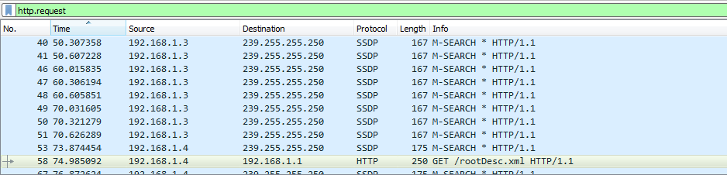

1. Display packets which are using TCP protocol
   * tcp

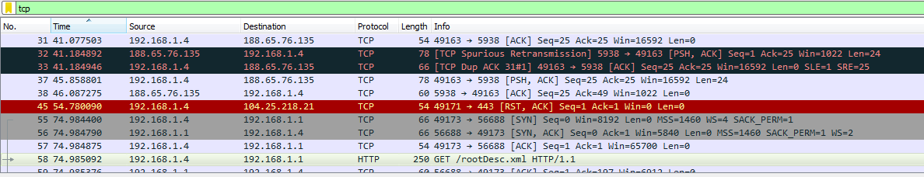

1. Display packets having no error connecting to server
   * http.response.code==200

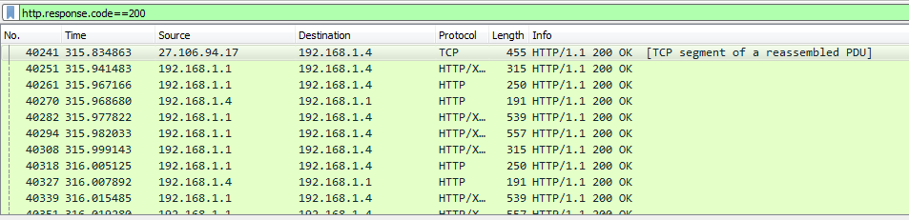

1. Display packets having port number 80
   * tcp.port==80 || udp.port==80

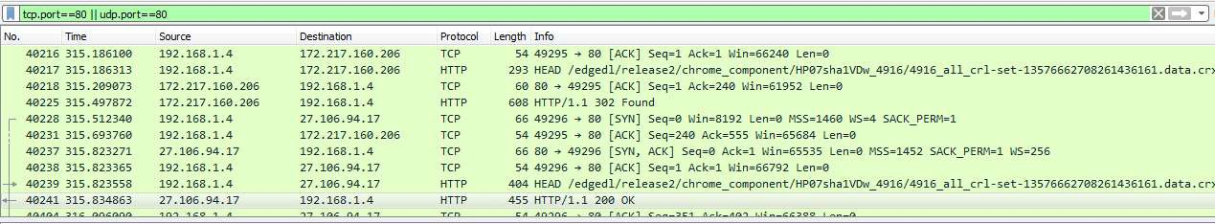

1. Display packets which that contains keyword facebook
   * tcp contains facebook

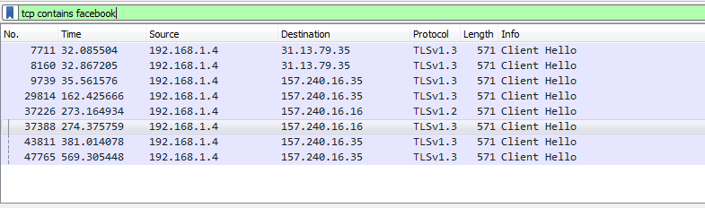

**Conclusion:**Thus,we have Capturing and analyzing network packets using Wireshark (Fundamentals).

**PRACTICAL NO 6**

Aim :- Analyze the packets provided in lab and solve the questions using Wireshark :

* What web server software is used by [www.snopes.com?](http://www.snopes.com/)
* About what cell phone problem is the client concerned?
* According to Zillow, what instrument will Ryan learn to play?
* How many web servers are running Apache?

## What web server software issued by [www.snopes.com?](http://www.snopes.com/)

**Analysis** **–** The domain name be found from host header so we will set host header column where we will see all domain name. Select any HTTP request and expand the Hypertext Transfer Protocol then right click on Host header and then Apply as Column.

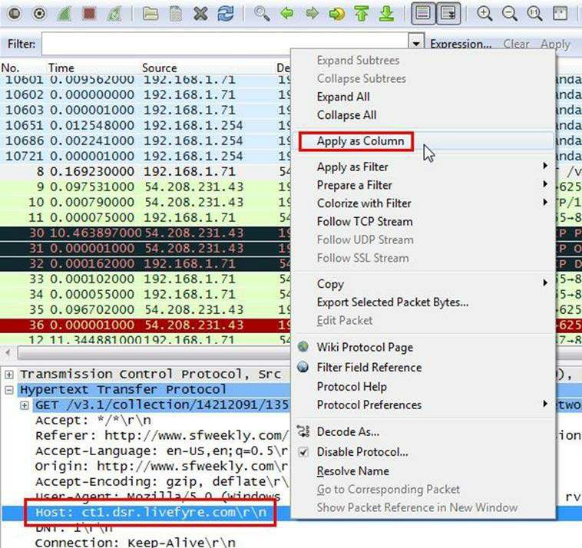

Now we can see our host [www.snopes.com](http://www.snopes.com/) in host column.

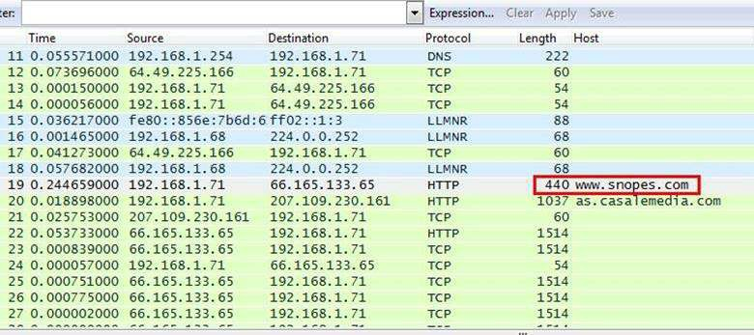

Right click on the selected packet and then select Follow TCP stream.

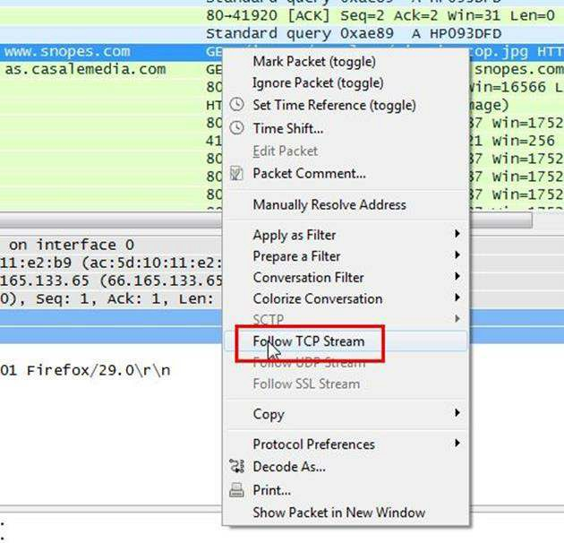

Now we can see the webserver name in server header it is Microsoft IIS 5.0

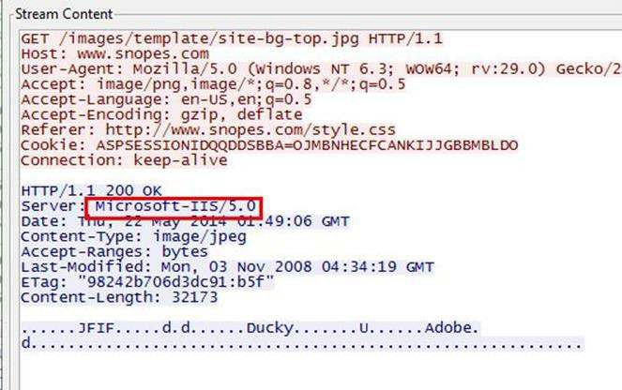

## About what cell phone problem is the client concerned?

**Analysis** **–** Client talking about cell so we search for cell keyword in whole packets. We will use regular express for searching the cell keyword. Apply frame matches “(?!) cell”

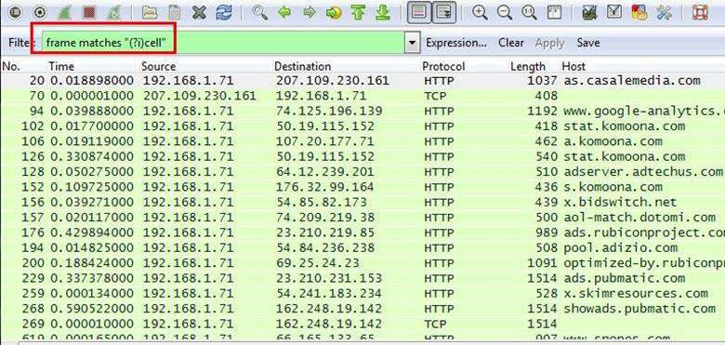

After applying the filter now, we will start to check every HTTP request. We noticed in the first HTTP request cell keyword is in URL and it was about cell phone charging issue.

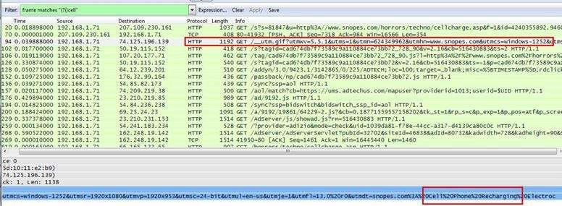

## According to Zillow, what instrument will Ryan learn to play?

Analysis – As we did in the last challenge, we will apply a regular express filter for the Zillow keyword. Apply frame matched “(?!) zillow”

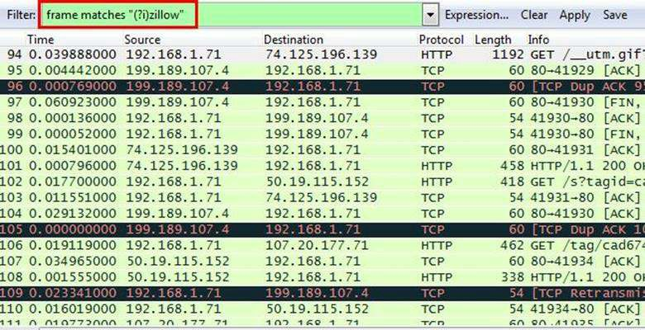

After applying the filter, we found only one packet with the Zillow keyword

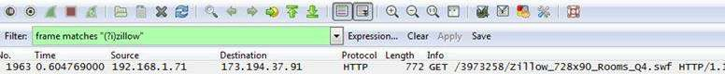

Select the packet and expand the Hypertext Transfer Protocol tab right click on it go to Protocol Preferences and check Allow subdissector to resemble TCP stream.

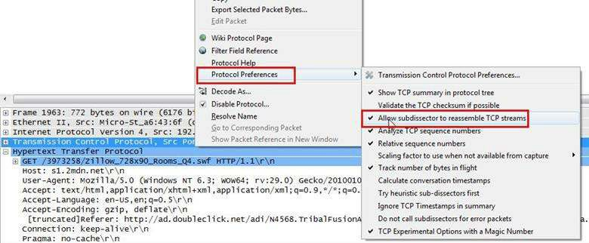

Now go to file and select Export Objects > HTTP. It will save all objects from the packet.

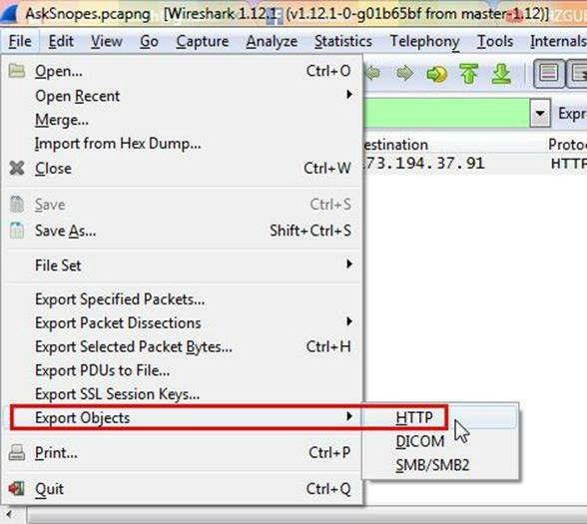

Click on save all.

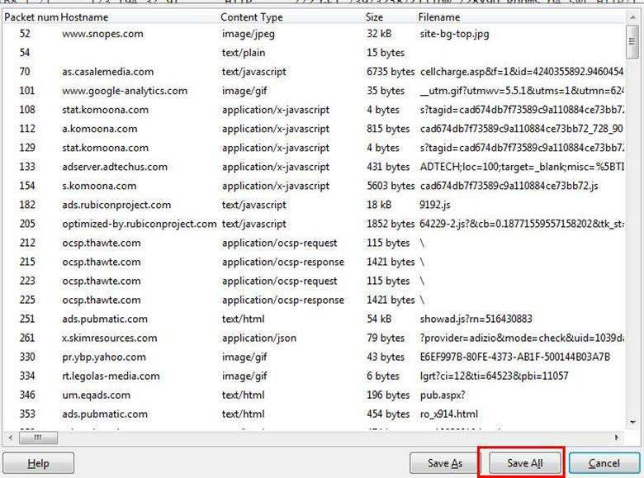

After saving all files in a directory and we found a swf file with name Zillow. After opening the flash file, we saw that Zillow was trying to learn saxophone.

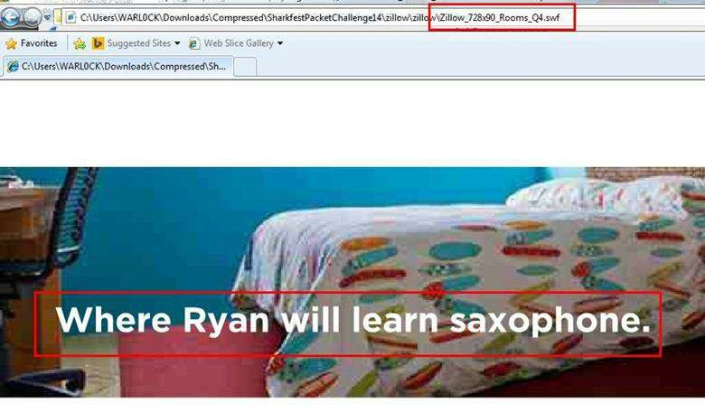

## How many web servers are running Apache?

**Analysis** **–** The web server name can be retrieved from HTTP response header. So will apply filter http. response and we can see all http response packets.

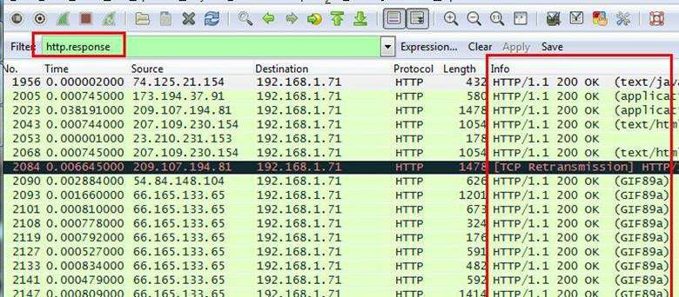

Now we will set the server header as column select any packet and right click on it then select Apply as Column.

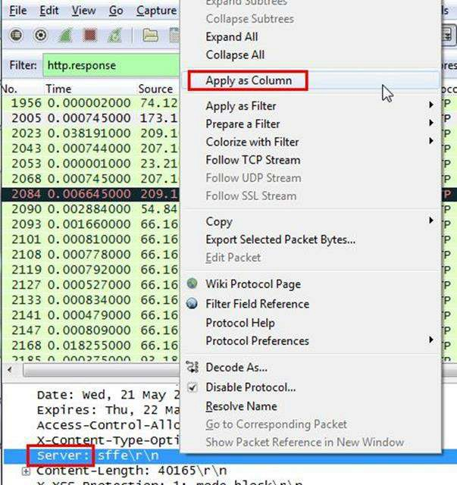

Now can see the server column where all server name is showing.

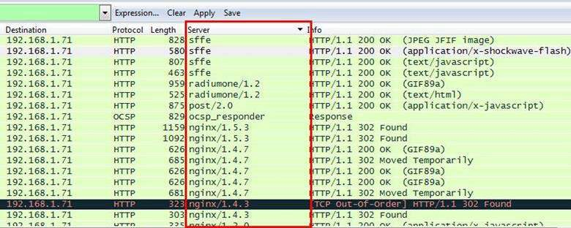

Now we have to check how many Apache packets are there we can’t count manually for each packet so we will apply another filter http.server contains “Apache”

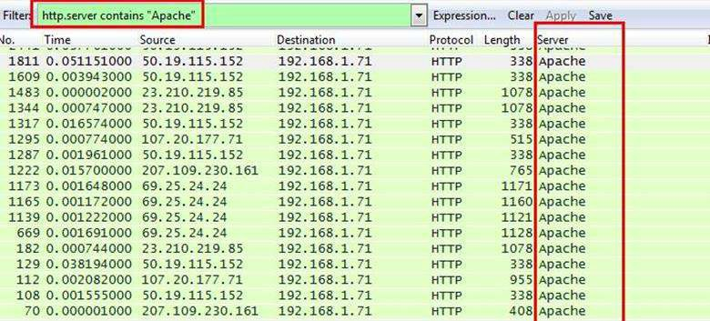

After applying filter go to Statistics > Endpoints

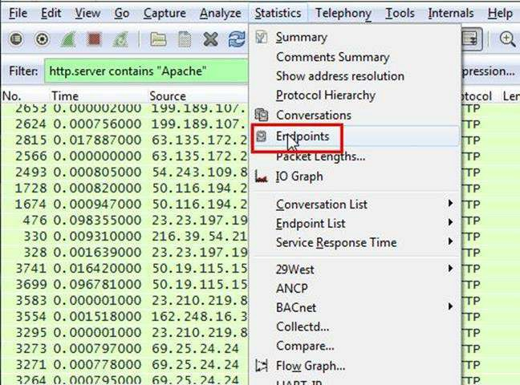

It will show all connections

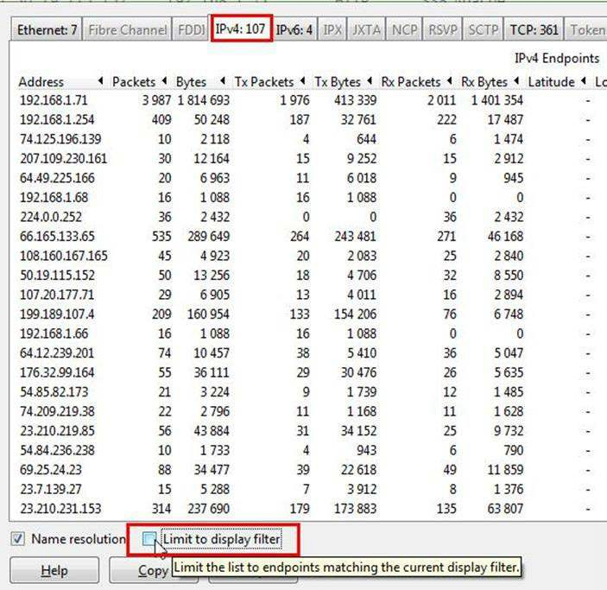

Check the limit to display filter then it will show the actual Apache connections. Now there are showing 22 connections but will exclude 192.168.1.71 because it is client’s IP not a server IP so there are actual 21 Apache servers.

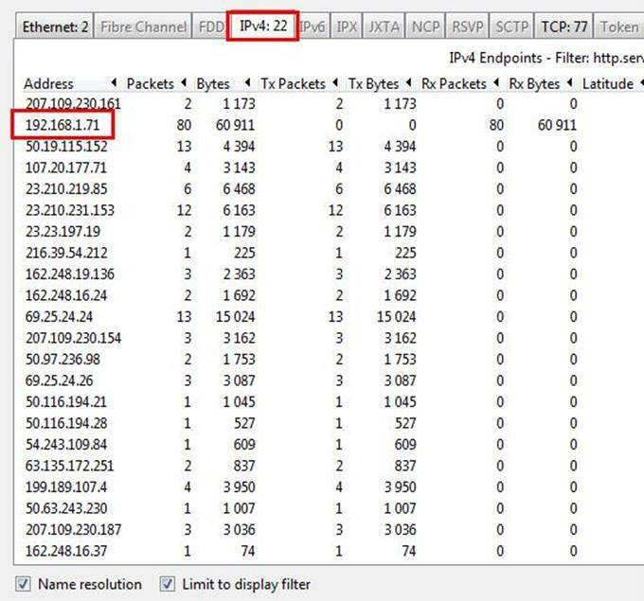

**CONCLUSION:** We have successfully analyzed the packets provided and solved the questions using wireshark.

**PRACTICAL NO 7**

**AIM : -** Recovering and Inspecting deleted files

**Software Required:**Forensic Tools

**Theory:**

* Check for Deleted Files
* Recover the Deleted Files
* Analyzing and Inspecting the recovered files

Step 1: Start Autopsy from Desktop.

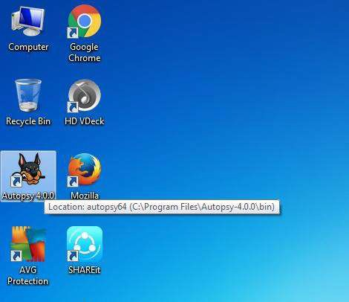



Step 2: Now create on New Case.

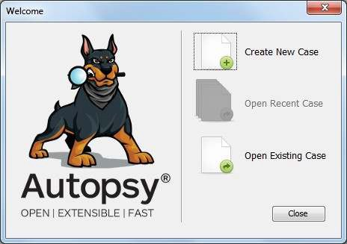

Step 3: Enter the New case Information and click on Next Button.

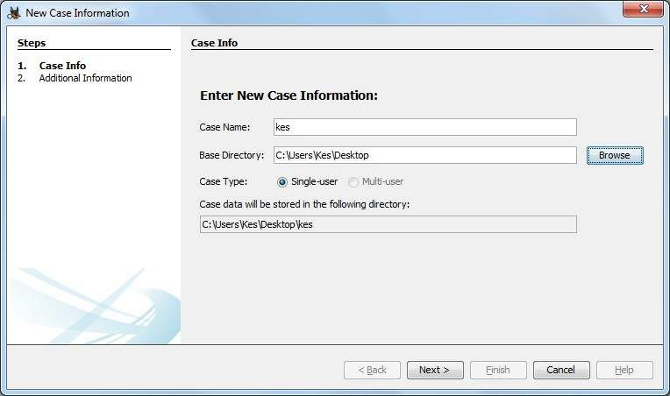

Step 4: Enter the additional Information and click on Finish.

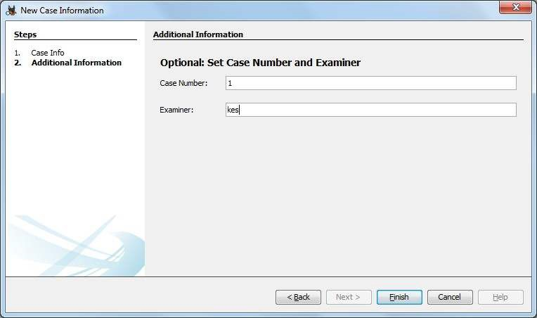

Step 5: Now Select Source Type as Local disk and Select Local disk form drop down list and click on Next.

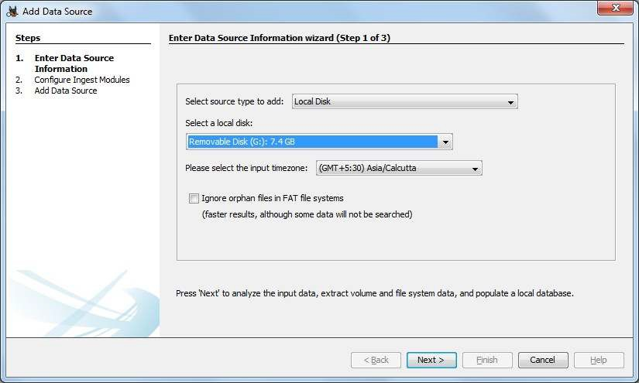

Step 6: Click on Next Button.

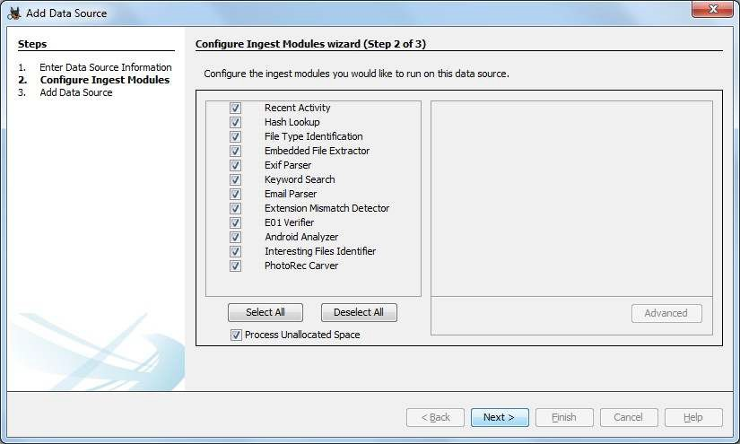

Step 7: Now click On Finish.

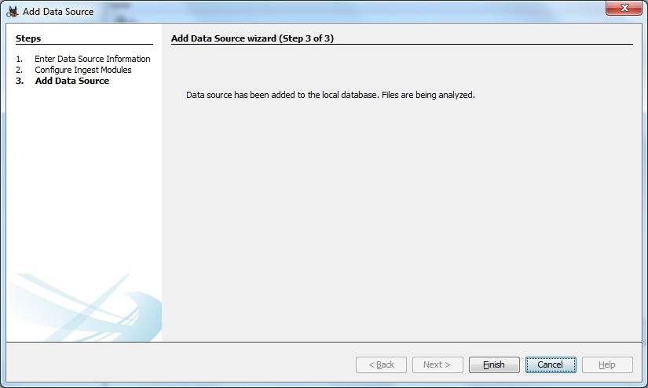

Step 8: Now Autopsy window will appear and it will analyzing the disk that we have selected.

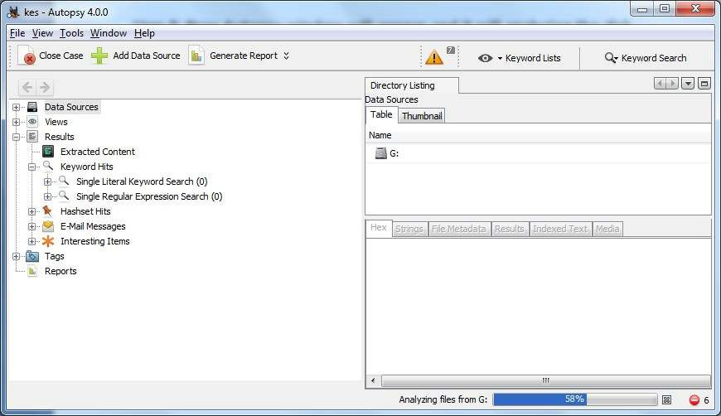

Step 9: All files will appear in table tab select any file to see the data.

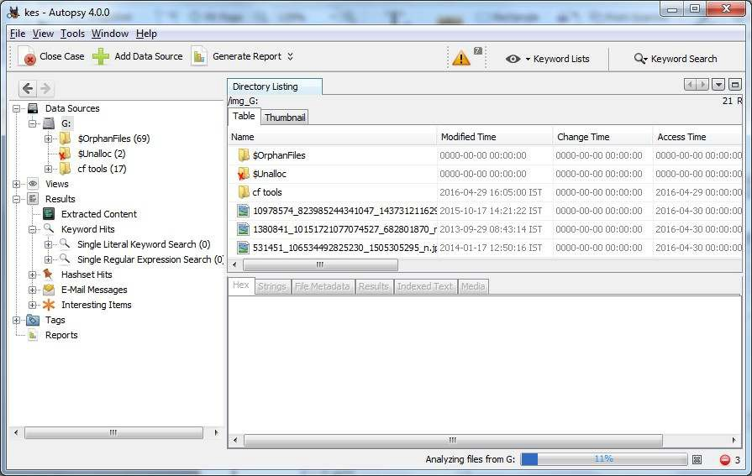

Step 10:Expand the tree from left side panel to view the document files.

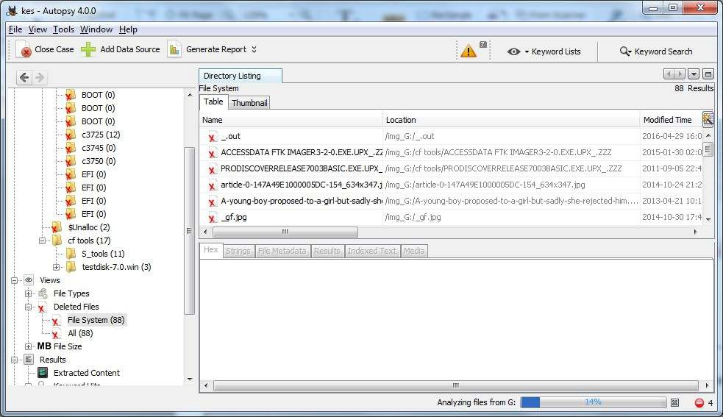

Step 11: To recover the file, go to view node-> Deleted Files node , here select any file and right click on it than select Extract Files option.

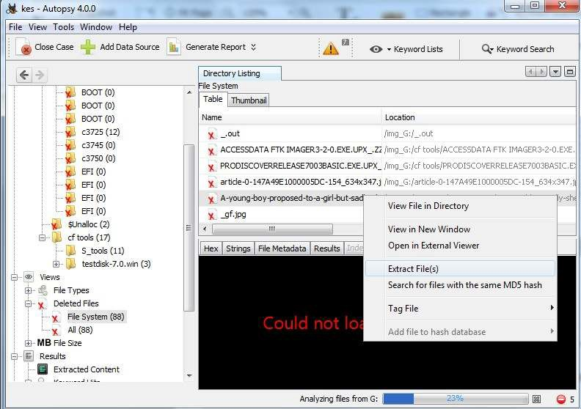

Step 12: By default Export folder is choose to save the recovered file.

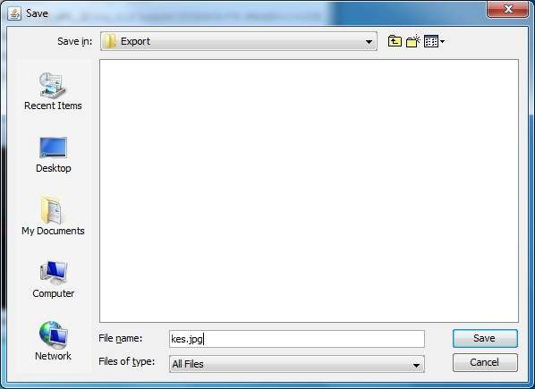

Sep 13 : Now Click on Ok.

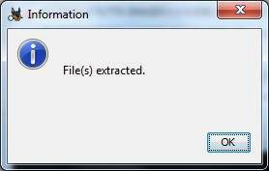

Step 14: Now go to the Export Folder to view Recover file.

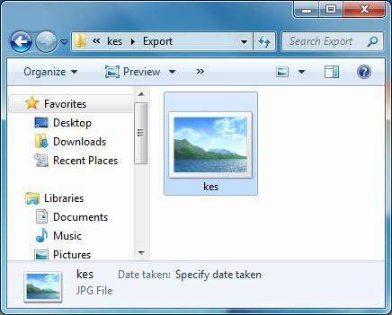

Step 15: Click on Generate Report from autopsy window and Select the Excel format and click on next.

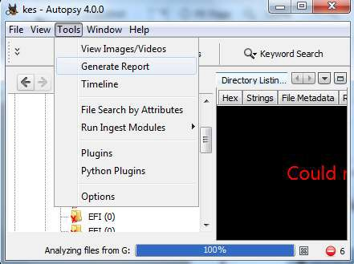

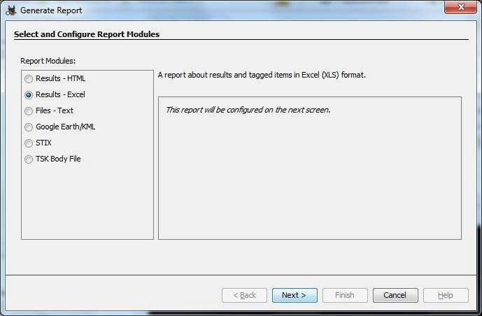

Step 16: Now Report is Generated So click on close Button .we can see the Report on Report Node.

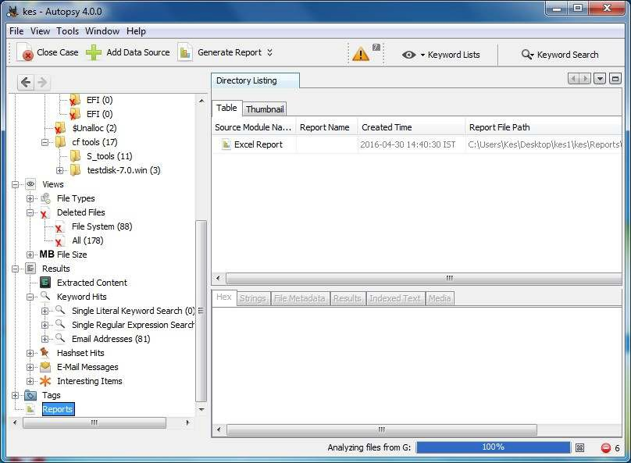

Step 17: Now open the Report folder and Open Excel File.

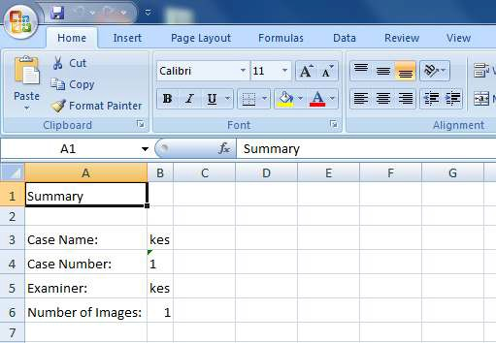

**Conclusion:**Thus,we have to successfully Recovering and Inspecting deleted files.

**PRACTICAL NO 8**

Aim :- Acquisition of Cell phones and Mobile devices .

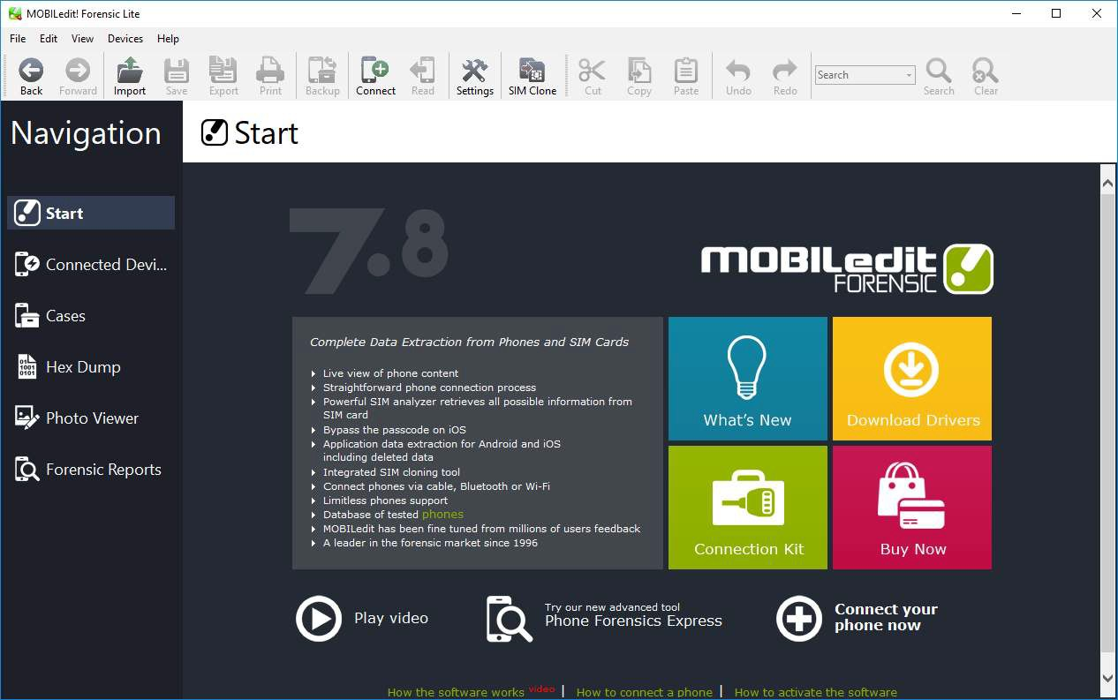

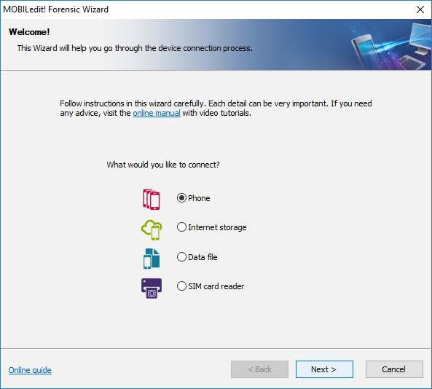

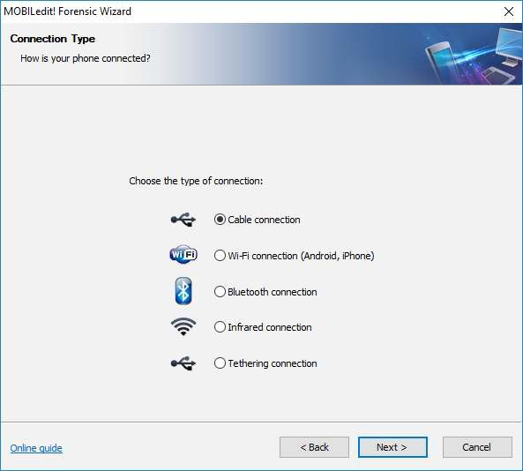

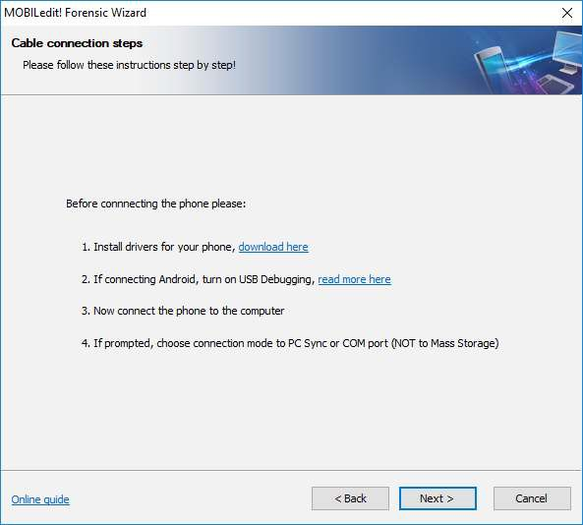

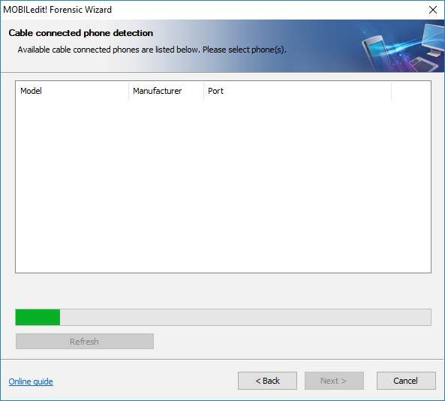

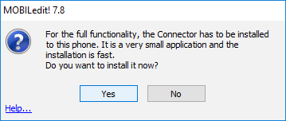

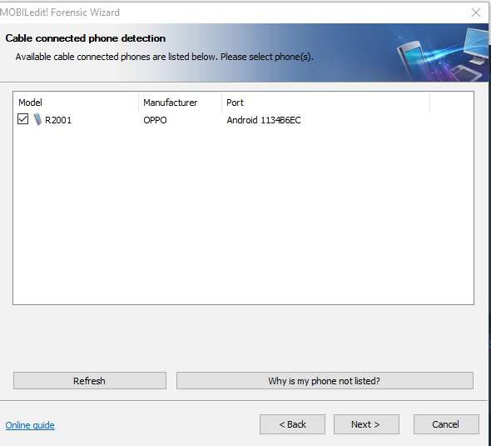

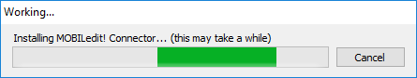

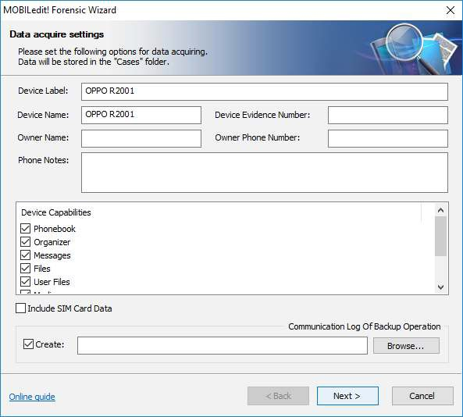

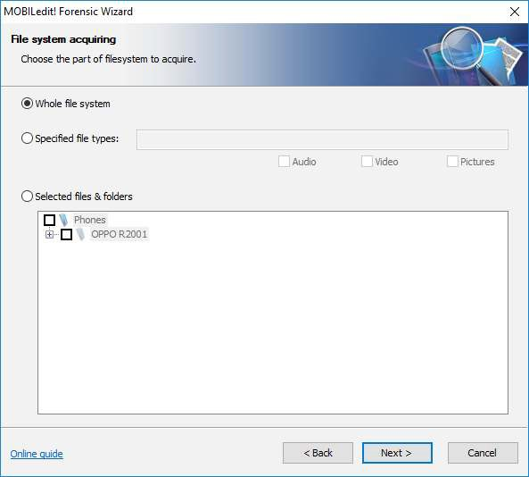

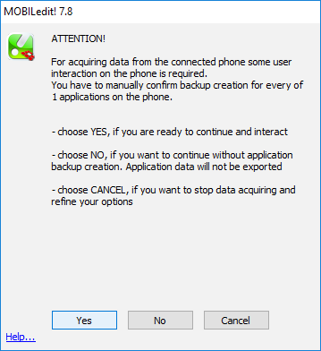

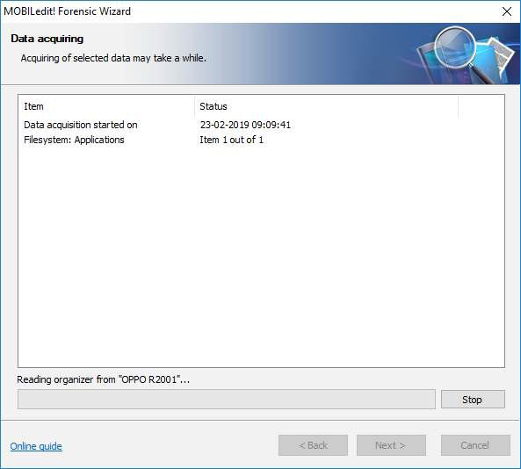

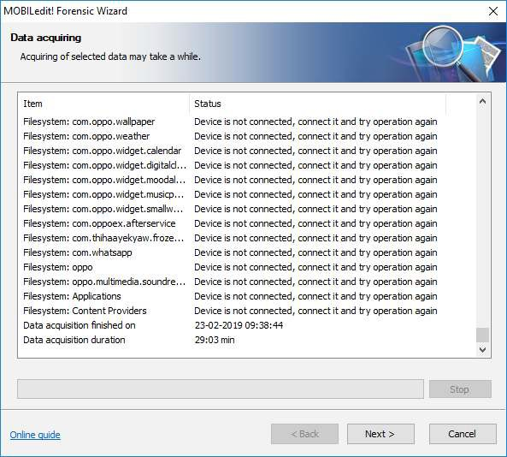

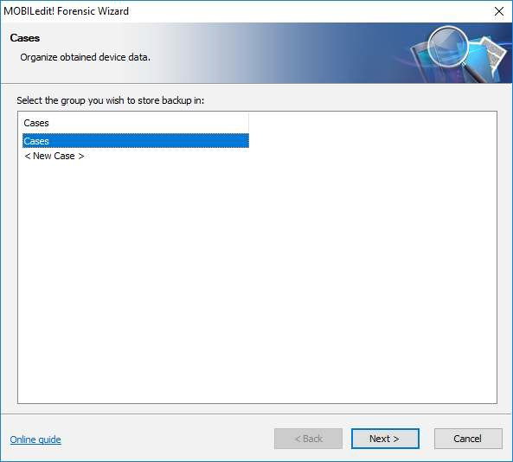

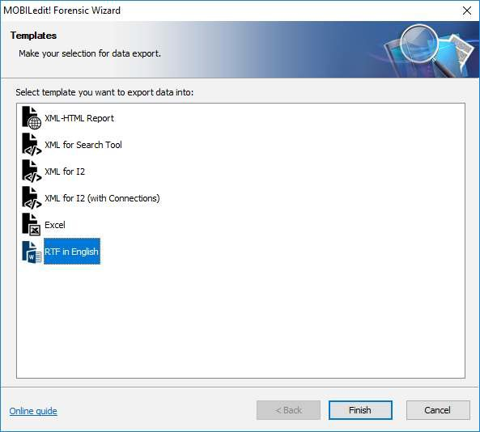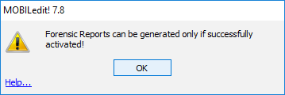

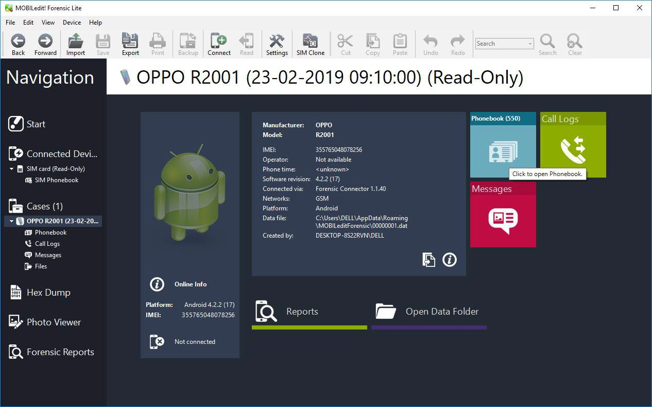

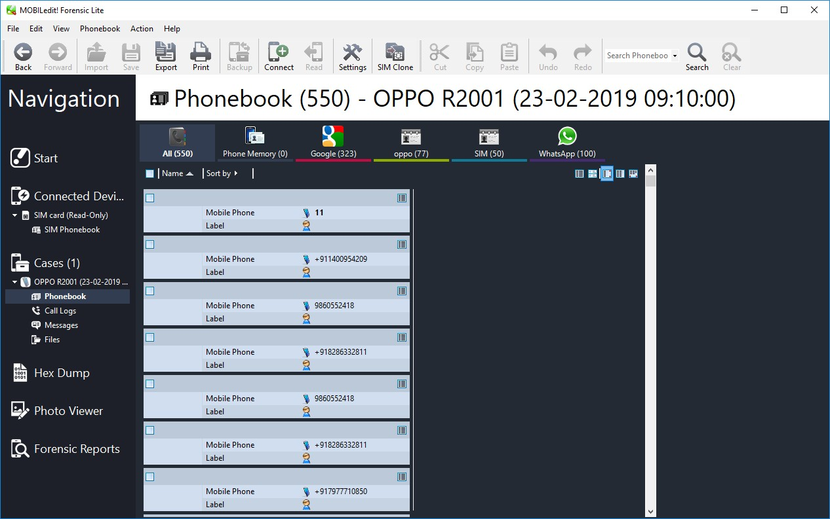

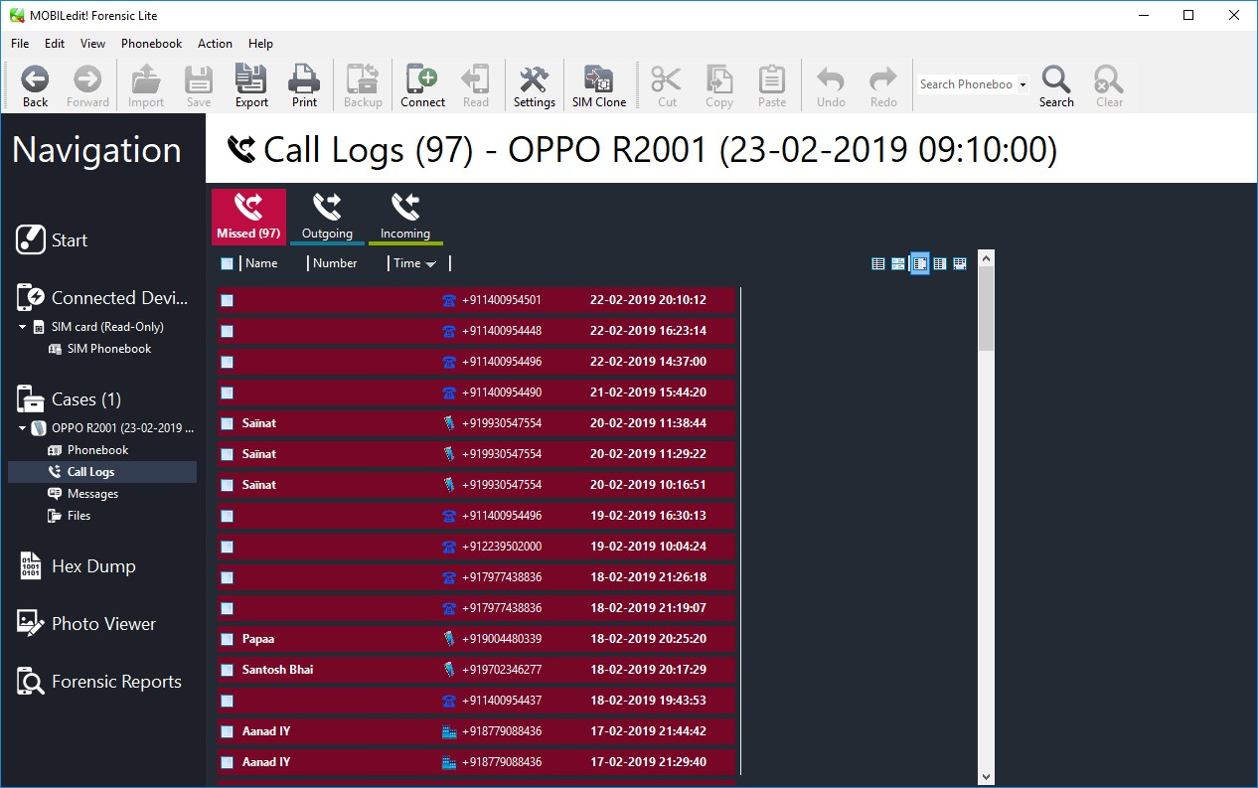

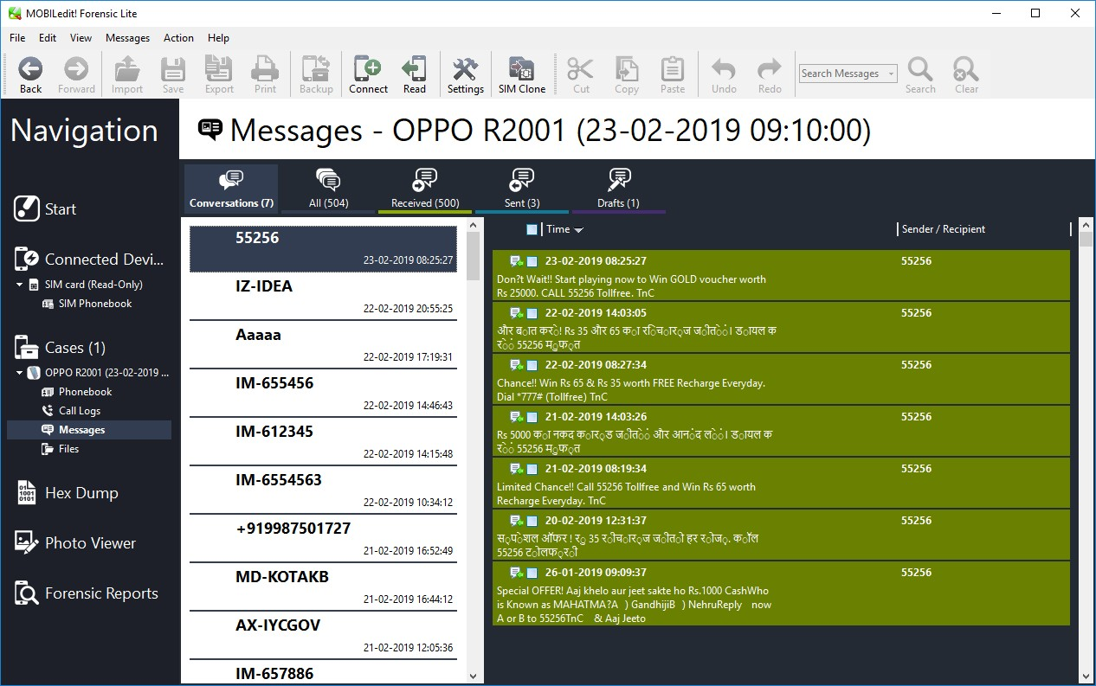

**Conclusion:**Thus,we have successfully perform Acquisition of Cell phones and Mobile devices .

**PRACTICAL NO 9**

**Aim :-** Email Forensics

**Software Required:** Email Forensic Tools.

**Theory:**

* Mail Service Providers
* Email protocols
* Recovering emails
* Analyzing email header

FTK can filter or find files specific to e-mail clients and servers. You can configure these filters when you enter search parameters.

Because of Jim’s responses to a poor performance review, the CEO of Superior Bicycles,Martha Dax, suspects he might have obtained sensitive information about the company’s business model that he’s leaking to a competitor.

Martha asked her CIO, to have an IT employee copy the Outlook .pst file from Jim Shu’s old computer to a USB

drive.

To process this investigation, we need to examine the Jim_shu’s.pst file, locate the message, and export it for further analysis of its header to see how Jim might have received it.

## Recovering Email

Start AccessData FTK and click **Start** **a** **new** **case**, then click **OK**. Click **Next** until you reach the **Refine** **Case** **-** **Default** dialog box Click

the **Email** **Emphasis** button , and then click **Next** **.**

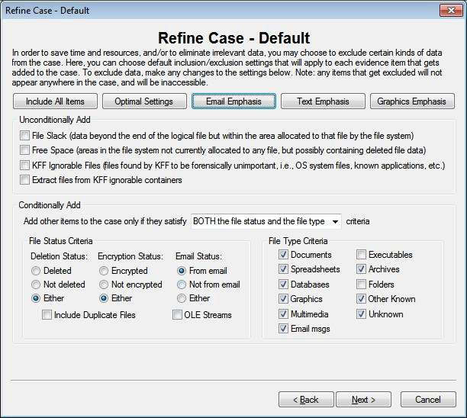

Click **Next** until you reach the **Add** **Evidence** **to** **Case** dialog box, and then click the **Add** **Evidence** button.

In the Add Evidence to Case dialog box, click the **Individual** **File**

option button, and then click **Continue**.

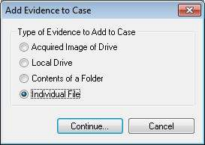

In the **Select** **File** dialog box, navigate to your work folder, click the

**Jim_shu’s.pst** **file**, and then click **Open**.

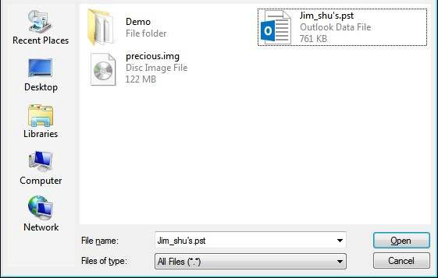

When the **Add** **Evidence** **to** **Case** dialog box opens, click **Next**. In the

**Case** **summary** dialog box, click **Finish**.

When FTK finishes processing the file, in the main FTK window, click the **E-** **mail** **Messages** button, and then click the **Full** **Path** column header to sort the records.

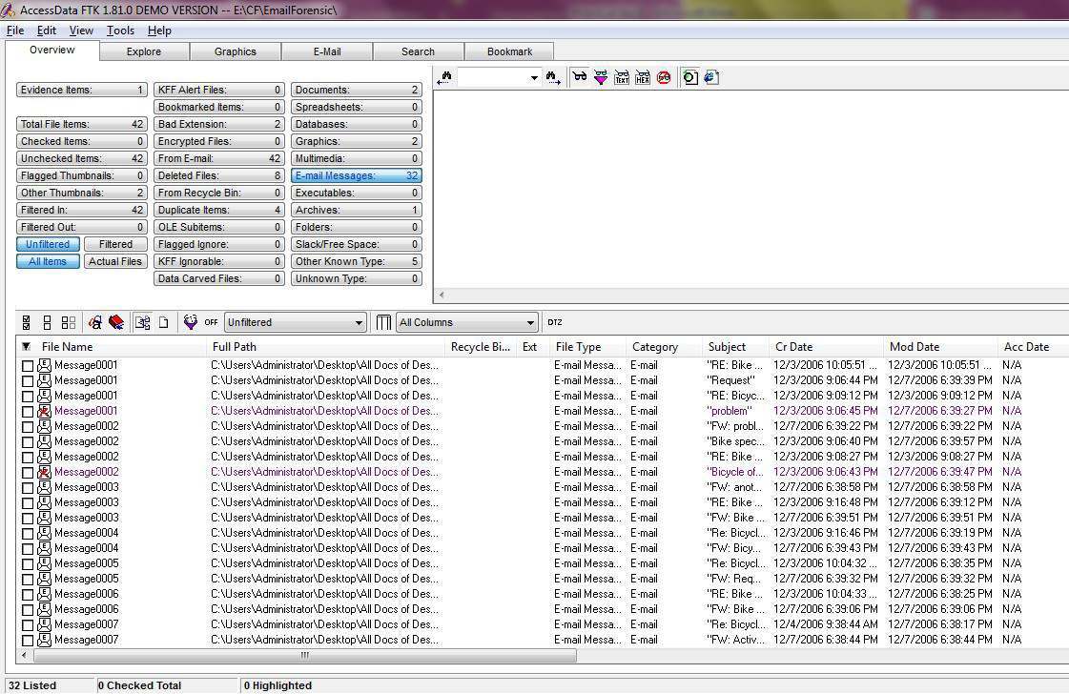

## For email recovery follow following steps:

Click the **E-Mail** tab. In the tree view, click to expand all folders, and then click the **Deleted** **Items** folder.

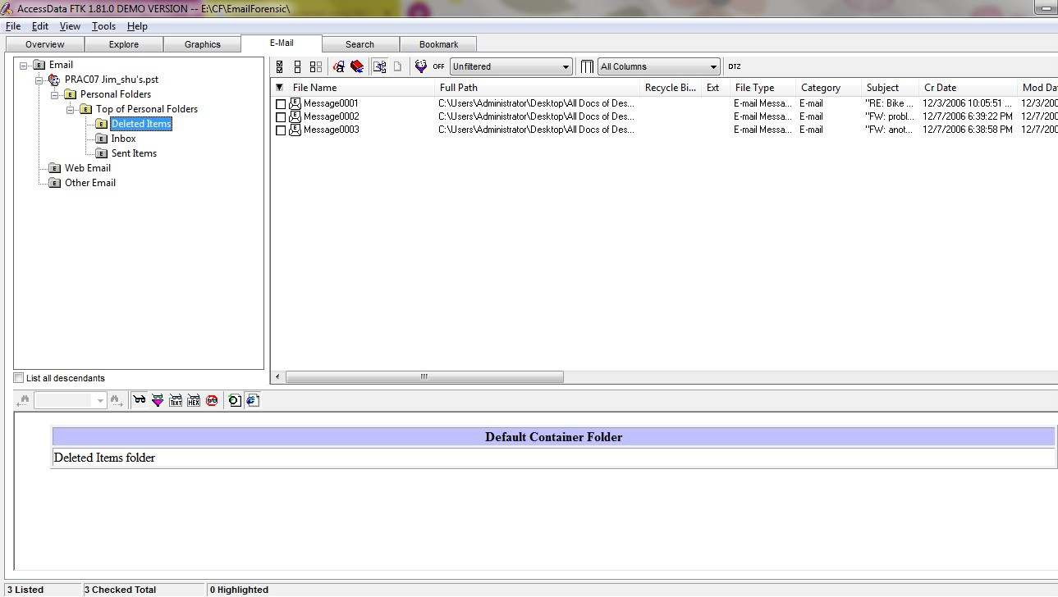

Select any message say Message0001 right click and select option Launch. Detached Viewer and you can see detail of deleted message.

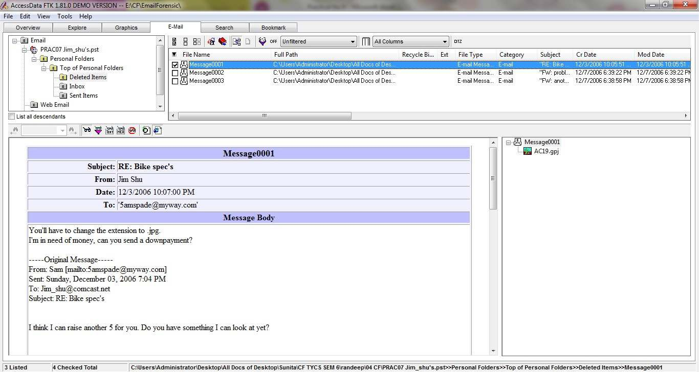

## For analyzing header follow following steps:

Click the **E-Mail** tab. In the tree view, click to expand all folders, and then click the **Inbox** folder.

In the File List pane at the upper right, click Message0003; as shown in the pane at the bottom, it’s from **Sam** and is addressed to **[Jim_shu@comcast.net.](mailto:Jim_shu@comcast.net)**

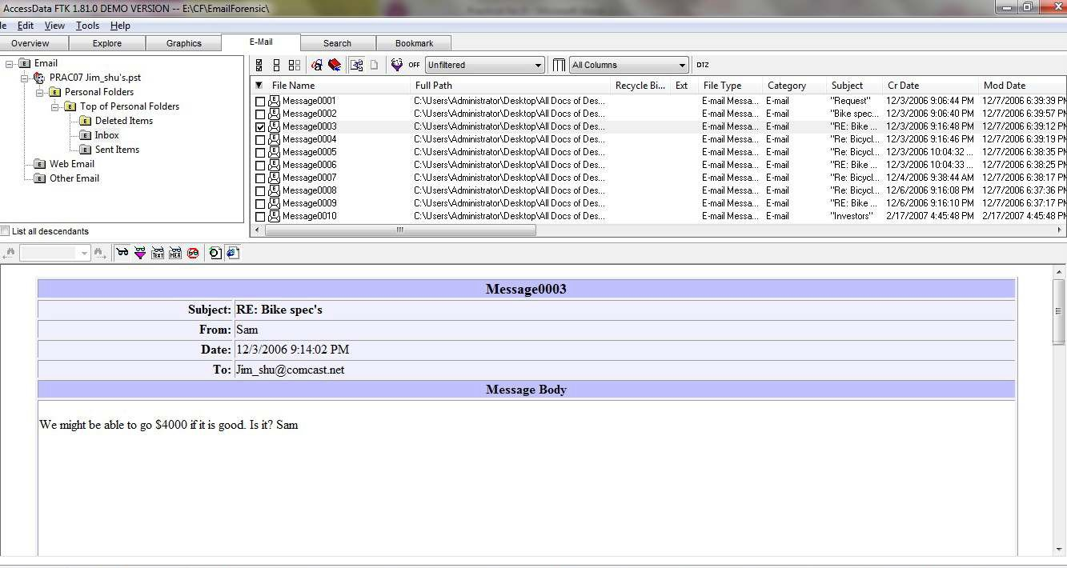

Right-click on any message say Message0003 in the File List pane and click Export File. In the Export Files dialog box, click OK.

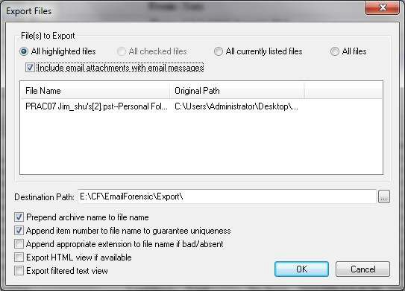

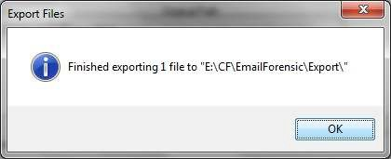

FTK saves exported files in the HTML format with no extension.

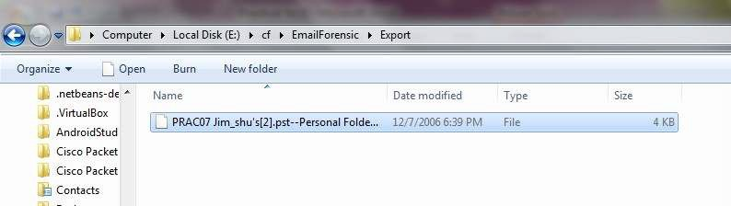

Right-click the Message0003 file and click Rename. Type Message0003.html and press Enter.

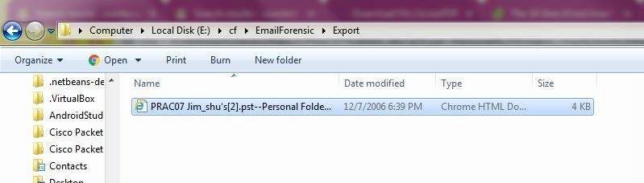

Double-click Message0003.html to view it in a Web browser.

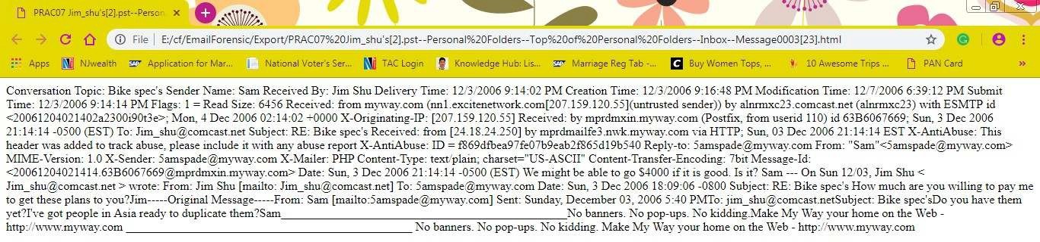

**Conclusion:**Thus ,we have to successfully perform Email Forensics

**PRACTICAL NO 1**

**AIM:** Introduction to Digital Forensics

**Theory:**

Computer Forensics is a scientific method of investigation and analysis in order to gather evidence from digital devices or computer networks and components which is suitable for presentation in a court of law or legal body. It involves performing a structured investigation while maintaining a documented chain of evidence to find out exactly what happened on a computer and who was responsible for it. 

Types of Digital Forensics:

Disk Forensics: It deals with extracting raw data from the primary or secondary storage of the device by searching active, modified, or deleted files.

Network Forensics: It is a sub-branch of Computer Forensics that involves monitoring and analyzing the computer network traffic.

Database Forensics: It deals with the study and examination of databases and their related metadata.

Malware Forensics: It deals with the identification of suspicious code and studying viruses, worms, etc.

Email Forensics: It deals with emails and their recovery and analysis, including deleted emails, calendars, and contacts.

Memory Forensics: Deals with collecting data from system memory (system registers, cache, RAM) in raw form and then analyzing it for further investigation.

Mobile Phone Forensics: It mainly deals with the examination and analysis of phones and smartphones and helps to retrieve contacts, call logs, incoming, and outgoing SMS, etc., and other data present in it.

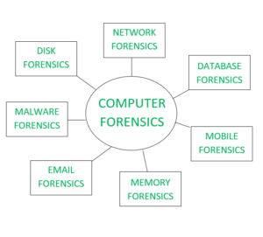

**Process of Digital Forensics:**

Identification: Identifying what evidence is present, where it is stored, and how it is stored (in which format). Electronic devices can be personal computers, Mobile phones, PDAs, etc.

Preservation: Data is isolated, secured, and preserved. It includes prohibiting unauthorized personnel from using the digital device so that digital evidence, mistakenly or purposely, is not tampered with and making a copy of the original evidence.

Analysis: Forensic lab personnel reconstruct fragments of data and draw conclusions based on evidence.

Documentation: A record of all the visible data is created. It helps in recreating and reviewing the crime scene. All the findings from the investigations are documented.

Presentation: All the documented findings are produced in a court of law for further investigations.

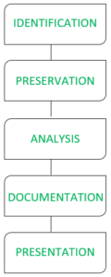

**APPLICATION**S

Intellectual Property theft

Industrial espionage

Employment disputes

Fraud investigations

Misuse of the Internet and email in the workplace

Forgeries related matters

Bankruptcy investigations

Issues concerned the regulatory compliance

**Advantages of Computer Forensics :**

To produce evidence in the court, which can lead to the punishment of the culprit.

It helps the companies gather important information on their computer systems or networks potentially being compromised.

Efficiently tracks down cyber criminals from anywhere in the world.

Helps to protect the organization’s money and valuable time.

Allows to extract, process, and interpret the factual evidence, so it proves the cybercriminal action’s in the court.

**Disadvantages of Computer Forensics :**

Before the digital evidence is accepted into court it must be proved that it is not tampered with.

Producing and keeping electronic records safe is expensive.

Legal practitioners must have extensive computer knowledge.

Need to produce authentic and convincing evidence.

If the tool used for digital forensics is not according to specified standards, then in a court of law, the evidence can be disapproved by justice.

A lack of technical knowledge by the investigating officer might not offer the desired result.

Conclusion:Thus,we study the Digital Forensics.